4.5 Code:
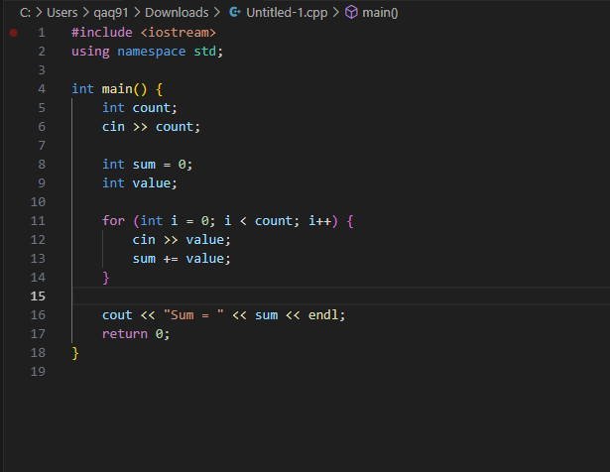
#include <iostream>
using namespace std;

int main() {
int count;
cin >> count;

int sum = 0;
int value;

for (int i = 0; i < count; i++) {
cin >> value;
sum += value;
}

cout << "Sum = " << sum << endl;
return 0;
}
4.5 Run:
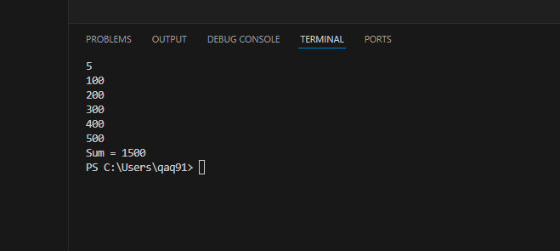
4.6 Code:
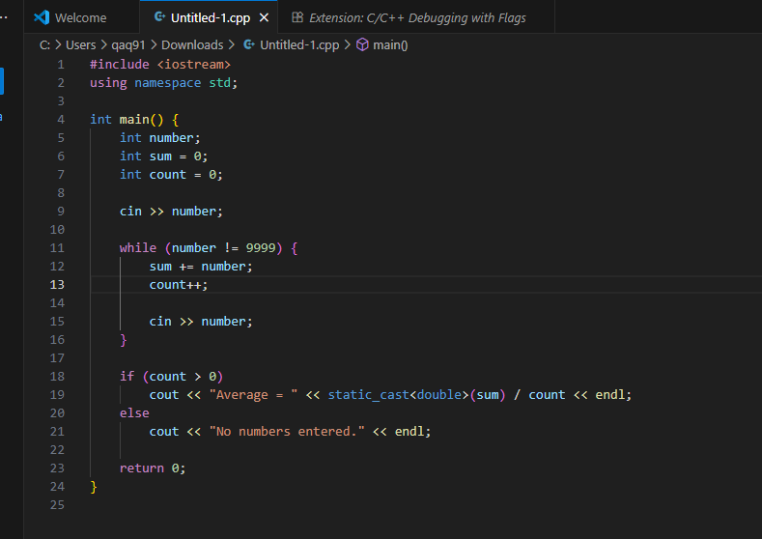
#include <iostream>
using namespace std;

int main() {
int number;
int sum = 0;
int count = 0;

cin >> number;

while (number != 9999) {
sum += number;
count++;

cin >> number;
}

if (count > 0)
cout << "Average = " << static_cast<double>(sum) / count << endl;
else
cout << "No numbers entered." << endl;

return 0;
}
4.6 Run:
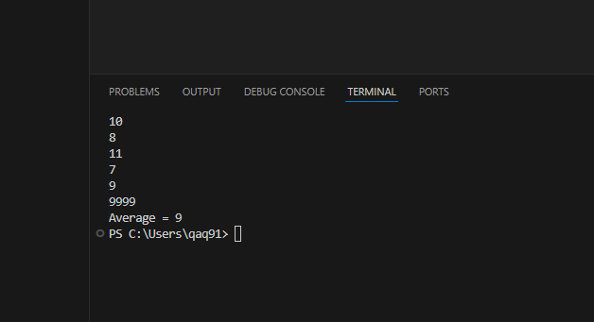

4.10 Code:
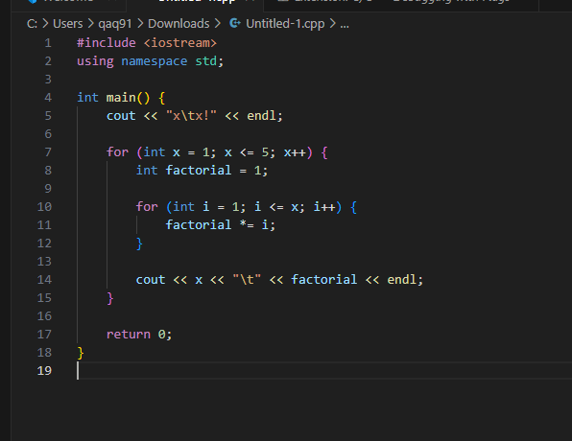
#include <iostream>
using namespace std;

int main() {
cout << "x\tx!" << endl;

for (int x = 1; x <= 5; x++) {
int factorial = 1;

for (int i = 1; i <= x; i++) {
factorial *= i;
}

cout << x << "\t" << factorial << endl;
}

return 0;
}
4.10 Run:
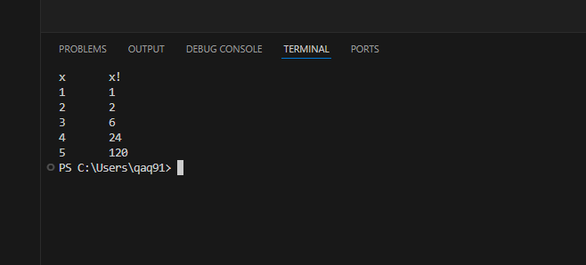為什麼無法算到 20？
因為：
int 會爆掉（overflow）
甚至 long long（最大約 9×10¹⁸）也無法表示 20!
而 20! ≈ 2.4 × 10¹⁸（剛好超過 long long 上限）
需要使用：
Big integer ( arbitrary precision )
或 C++ 的 boost::multiprecision::cpp_int

